Using CAL Archives
(Car files)
Contributor: Joseph Wong
Last modified: June 13, 2007
Copyright (c) 2007 BUSINESS OBJECTS SOFTWARE LIMITED
All rights reserved.
Redistribution and use in source and binary forms, with or without modification, are permitted provided that the following conditions are met:
- Redistributions of source code must retain the above copyright notice, this list of conditions and the following disclaimer.
- Redistributions in binary form must reproduce the above copyright notice, this list of conditions and the following disclaimer in the documentation and/or other materials provided with the distribution.
- Neither the name of Business Objects nor the names of its contributors may be used to endorse or promote products derived from this software without specific prior written permission.
THIS SOFTWARE IS PROVIDED BY THE COPYRIGHT HOLDERS AND CONTRIBUTORS "AS IS" AND ANY EXPRESS OR IMPLIED WARRANTIES, INCLUDING, BUT NOT LIMITED TO, THE IMPLIED WARRANTIES OF MERCHANTABILITY AND FITNESS FOR A PARTICULAR PURPOSE ARE DISCLAIMED. IN NO EVENT SHALL THE COPYRIGHT OWNER OR CONTRIBUTORS BE LIABLE FOR ANY DIRECT, INDIRECT, INCIDENTAL, SPECIAL, EXEMPLARY, OR CONSEQUENTIAL DAMAGES (INCLUDING, BUT NOT LIMITED TO, PROCUREMENT OF SUBSTITUTE GOODS OR SERVICES; LOSS OF USE, DATA, OR PROFITS; OR BUSINESS INTERRUPTION) HOWEVER CAUSED AND ON ANY THEORY OF LIABILITY, WHETHER IN CONTRACT, STRICT LIABILITY, OR TORT (INCLUDING NEGLIGENCE OR OTHERWISE) ARISING IN ANY WAY OUT OF THE USE OF THIS SOFTWARE, EVEN IF ADVISED OF THE POSSIBILITY OF SUCH DAMAGE.

Contents
1 Introduction 1
2 Cars, Vaults, and Workspaces 1
2.1 Cars and the StandardVault 1
2.1.1 Directory Structure 1
2.1.2 Using Car-jars with the Java classpath 2
2.2 Importing a Car in a Workspace Declaration 2
2.3 Car Workspace Spec files 2
2.4 Module resources in Cars 3
2.5 Sourceless modules in Cars 3
3 Building a Car 3
3.1 Building a single Car 3
3.1.1 In ICE 3
3.1.2 In GemCutter 4
3.1.3 Using the command line tool 5
3.2 Building one Car per imported Workspace Declaration 6
3.2.1 In ICE 7
3.2.2 In GemCutter 7
3.2.3 Using the command line tool 8
4 Trying out Car Files in a Development Environment 9
4.1 Using regular Car files 9
4.1.1 ICE 9
4.1.2 GemCutter 12
4.2 Using Car-jar files 13
4.2.1 Setup for ICE and GemCutter 13
5 Deployment Scenarios for Cars 16

Introduction
A CAL Archive – also called a Car file for short – is a file format based on the zip/jar file format and is used for aggregating files which constitute CAL resources. In particular, a Car file may contain:
- Workspace declaration files
- CAL source files
- cmi files (compiled module files)
- lc files (our custom-loaded lecc generated class files)
- metadata files
- gem design files
- user resource files

Car files are intended to be used as a deployment mechanism: instead of deploying CAL modules as a set of source files and resource files, these modules can be packaged into a small number of Car files, so that they can be distributed and deployed more easily. Section 5 contains a more in-depth discussion on various deployment strategies using Car files.

Cars, Vaults, and Workspaces
While a Car acts as a container of CAL resources, a Car itself is also a CAL resource. In particular, a Car is a read-only resource: the contents of a Car file cannot be modified at runtime.
As with other CAL resources, Car files are located in repositories known as vaults, such as the StandardVault (representing the Java classpath) or the SimpleCarFileVault (representing a standalone Car file).
On the other hand, resources contained within a Car are always fetched directly from the Car without going through the intermediate step of copying the uncompressed contents onto disk.

Cars and the StandardVault
There are two ways to use Car files with the StandardVault: 1) by putting the files in a particular directory under the regular StandardVault scheme, and 2) by adding Car-jar files (see Section 2.1.2) to the Java classpath.

Directory Structure
Similar to other types of resources such as CAL source files and workspace declaration files, Car files are grouped in their own directory for the StandardVault. This directory is named “Car” – note that this name is case sensitive: uppercase “C” and lowercase “ar”.
The “Car” directory is the analog of the “CAL” directory for CAL source files and the “Workspace Declarations” directory for workspace declaration files. For example, the following figure shows a directory structure that includes some Car files stored in the appropriate place:
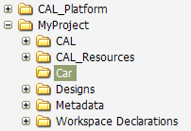

Using Car-jars with the Java classpath
As an alternative to putting Car files in a “Car” directory, one can add Cars to the StandardVault by putting them directly on the Java classpath. Unlike regular Car files, these variant Cars – called Car-jars – will have names ending with a .car.jar suffix, and will employ the Jar file format.
Even though a Car-jar file has a .car.jar suffix (e.g. cal.platform.car.jar), the .jar suffix is dropped for the actual name of the Car as recognized by the CAL runtime (e.g. cal.platform.car.jar is the Car-jar defining the Car cal.platform.car).
In terms of precedence, the Cars located in the StandardVault's regular directory structure take precedence over the Car-jars on the classpath.
The workspace declaration files contained within a Car-jar are recognized as files in the StandardVault, and thus can be referenced and imported in the same way as other workspace declaration files occurring in “Workspace Declarations” directories.

Importing a Car in a Workspace Declaration
To reference a Car in a workspace declaration, include a line:
import car StandardVault test.car main.carspec
where StandardVault refers to the vault where the Car file could be found, test.car is the name of the Car, and main.carspec is the name of the Car Workspace Spec file within the Car (see Section 2.3).

Car Workspace Spec files
A Car Workspace Spec (or Carspec for short) is a whitespace delimited list of module names, either representing all the modules in the Car, or just a proper subset thereof. The Carspec is the unit for importing modules from a Car into the workspace.
A Car file may contain more than one Carspec file. Many of the tools for building Cars default to using the name main.carspec for the Carspec file that represents all the modules in the Car.

Module resources in Cars
If a module is defined in a Car, then all its resources (e.g. the CAL source file, metadata files, user resource files) must also be encapsulated within the same Car. The runtime maintains a mapping from a module name to the corresponding location where resources for the module are to be found – either on disk or from a particular Car file.
In a workspace where all modules come from a set of Cars, no compilation should take place when the workspace is initialized, and there should be no lecc_runtime directory generated on disk, as all program runtime resources are fetched directly from the Car.

Sourceless modules in Cars
It is possible to deploy a Car file that does not contain any CAL source files. Modules that are deployed without source are called sourceless modules. These sourceless modules are loaded directly from the corresponding cmi files.
For these modules, the Car file will contain empty stub files in lieu of the original source files.

Building a Car
There are currently a number of ways to construct a Car out of an existing CAL workspace.

Building a single Car
One way to build Car files is to simply package up all the resources in the current workspace into a single Car.

In ICE
To package up the contents of the current workspace in ICE, use the :car command. For example, in ICE, one may type:
:car c:\temp
This will construct a new Car file c:\temp\Car\ice.default.car containing all modules and their associated resources in the current working workspace (i.e. ice.default.cws). Note that the Car file is generated under a subdirectory called Car. This is to facilitate the use of the generated Car directly in its output location (as described in more detail in Section 4).
Included in the Car will be a file named main.carspec, which is a Carspec file containing the names of all the modules.
Also generated along with the Car file will be a corresponding workspace declaration file that can be used to import the Car. This file, named ice.default.car.cws, will be located in c:\temp\Workspace Declarations.
The full syntax of the :car command is as follows:
:car [-keepsource] [-nocws | -nosuffix] [-s] [-jar] [-d] <output directory>
- By default, the Car is built with sourceless modules. If -keepsource is specified, then the generated Cars will contain the full source of the modules.
- If -nocws is specified, then a new workspace declaration file will not be generated for each output Car.
- If -nosuffix is specified, then the workspace declaration files generated will end simply with .cws rather than .car.cws.
- If -s is specified, then the modules that come from Cars will be skipped over in the output Cars.
- If –jar is specified, then Car-jars will be generated instead of regular Car files. In this case, the output files will be placed directly under the specified output directory, rather than in a Car subfolder. If -nocws is not specified, then the new workspace declaration file will be packaged inside the Car-jar.
- If -d is specified, then a Car file is created in the given directory for every workspace declaration file imported by the current workspace. (See Section 3.2.1)

In GemCutter
To package up the contents of the current workspace in the GemCutter, go to the Workspace menu and select the menu item “Export to CAL Archives…”. From the options presented in the dialog, choose “Create a single CAL Archive file”, then use the Browse button below to provide the name of the output directory.
Similar to the :car command in ICE, the new Car will contain all the modules and their resources in the workspace, and also a corresponding main.carspec file.
The options -keepsource, -nocws, -nosuffix, -s and -jar available in ICE are also accessible via the dialog in the “Other options” section:
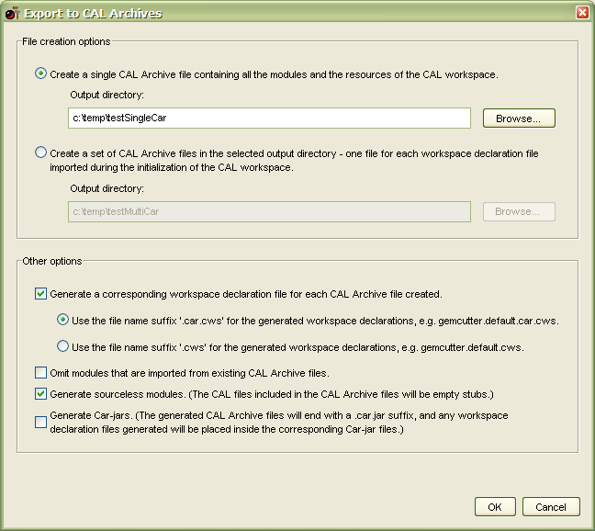

Using the command line tool
The command line tool for building Cars is provided by the class org.openquark.cal.services.CarTool, and it can be invoked by creating an Eclipse run target on the class.
The command line syntax for this tool is as follows:
java org.openquark.cal.services.CarTool
[workspaceDeclaration
| -multi workspaceDeclaration... --]
[-notVerbose] [-keepsource] [-nocws | -nosuffix] [-s]
[-excludeCarsInDirs carName ... --] [-excludeCarJarsInDirs carName ... --]
[-jar] outputDirectory [specFileName ...]
Where:
- workspaceDeclaration is the name of the workspace declaration file (e.g. ice.default.cws) which will form the basis of the modules that are included in the Car.
- If -multi is specified, then one Car will be generated per workspace declaration file appearing between -multi and --.
- If -notVerbose is specified, then additional diagnostic information will not be displayed.
- If –excludeCarsInDirs is specified, then the Cars found in the ‘Car’ subdirectories of the listed directories will not be generated.
- If –excludeCarJarsInDirs is specified, then the Car-jars found in the listed directories will not be generated.
- If –jar is specified, then Car-jars will be generated instead of regular Car files. In this case, the output files will be placed directly under the specified output directory, rather than in a Car subfolder. If -nocws is not specified, then the new workspace declaration file will be packaged inside the Car-jar.
- outputDirectory is the name of the output directory to which the single Car file will be generated (under a Car subfolder).
- [specFileName ...] is an optional list of additional Carspec files to be included with the Car. A main.carspec file is added to the Car by default.
- The options -keepsource, -nocws, -nosuffix and -s retain the same meaning as in the ICE :car command.

Building one Car per imported Workspace Declaration
Another approach to building Car files is to build a set of Car files from one workspace. In particular, we support the building of one Car file per workspace declaration file that constitutes the initial declaration of the CAL workspace.
For example, suppose we have the following workspace declaration files:
a.cws:
StandardVault Cal.Core.Prelude
StandardVault Foo
b.cws:
StandardVault Bar
StandardVault Baz
import StandardVault a.cws
c.cws:
StandardVault RunModule
import StandardVault b.cws
Suppose then that the CAL workspace is initialized with the declaration c.cws, we can build three Cars which correspond to the three workspace declaration files:
a.car: containing modules Cal.Core.Prelude and Foo
b.car: containing modules Bar and Baz
c.car: containing module RunModule

In ICE
To build one Car per workspace declaration file in ICE, use the :car command and specify the -d option. For example:
:car –d c:\cars
This will construct the set of Car files in the output directory c:\cars. Included in each Car will be a Carspec file named main.carspec, containing the names of the modules in that Car.
The command line options -keepsource, -nocws, -nosuffix, -s and -jar can also be used in conjunction with the -d option.

In GemCutter
To build one Car per workspace declaration file in GemCutter, go to the Workspace menu and select the menu item “Export to CAL Archives…”. From the options presented in the dialog, choose “Create a set of CAL Archive files”, then use the Browse button below to provide the name of the output directory.
For example:
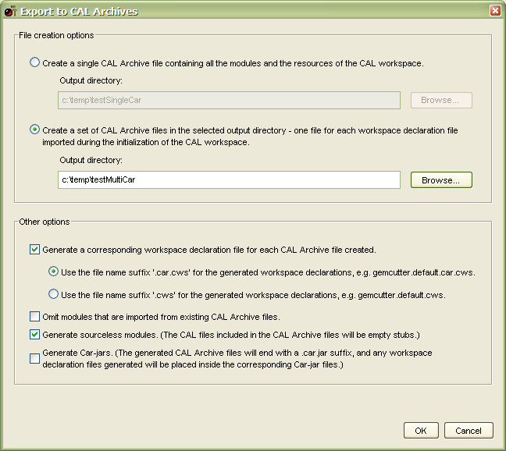

Using the command line tool
The command line tool can be invoked with the -d option as well, using the following syntax:
java org.openquark.cal.services.CarTool
[workspaceDeclaration | -multi workspaceDeclaration... --]
[-notVerbose] [-keepsource] [-nocws | -nosuffix] [-s]
[-excludeCarsInDirs carName ... --] [-excludeCarJarsInDirs carName ... --]
[-jar] –d outputDirectory
Where:
- workspaceDeclaration is the name of the workspace declaration file (e.g. ice.default.cws). A Car will be built for this file, and also for each workspace declaration transitively imported by this file.
- If -multi is specified, then the generated Cars will be based on the set of workspace declaration files between -multi and --.
- If -notVerbose is specified, then additional diagnostic information will not be displayed.
- If –excludeCarsInDirs is specified, then the Cars found in the ‘Car’ subdirectories of the listed directories will not be generated.
- If –excludeCarJarsInDirs is specified, then the Car-jars found in the listed directories will not be generated.
- If –jar is specified, then Car-jars will be generated instead of regular Car files. In this case, the output files will be placed directly under the specified output directory, rather than in a Car subfolder. If -nocws is not specified, then the new workspace declaration files will be packaged inside the corresponding Car-jars.
- outputDirectory is the name of the output directory.
- The options -keepsource, -nocws, -nosuffix and -s retain the same meaning as in the ICE :car command.

Trying out Car Files in a Development Environment
One simple way to try using Car files in a development environment is to extend the StandardVault to include the generated Car files and workspace declaration files. There are two different methods to do so: using regular Car files, and using Car-jar files. (See Section 2.1)

Using regular Car files
The CAL runtime will recognize the Car files if the root output directory (i.e. the parent of the generated subdirectories “Car” and “Workspace Declarations”) is added to the Java classpath.
For example, suppose one had generated some Car files in ICE using:
:car –d c:\testCar
Then, c:\testCar should be added to the front of the Java classpath.
Also, one needs to inform the CAL program in question (e.g. ICE or GemCutter) to use one of the generated workspace declarations so that the CAL workspace will be initialized with the contents of the Cars.
We will outline the entire process of setting up ICE and GemCutter in the Eclipse environment in the following sections.

ICE
First, set up an Eclipse run target for ICE.

Modifying the Java Classpath
To add the generated Car files and workspace declaration files to the Java classpath, edit the properties of the run target and navigate to the Classpath tab. Once there, select the “User Entries” tree node in the Classpath panel, then click the “Advanced…” button.
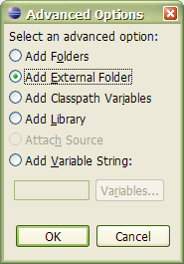

Select “Add External Folder” in the Advanced Options dialog, and click OK. A directory selector will then pop up, where the root output folder containing the “Car” and “Workspace Declarations” subfolders should be selected:
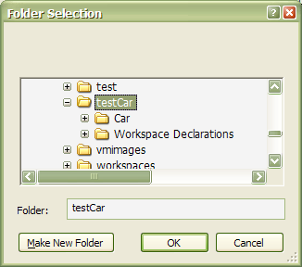
Afterwards, use the “Up” button to position this new classpath entry to the top of the “User Entries” section.
The final result should look like this:
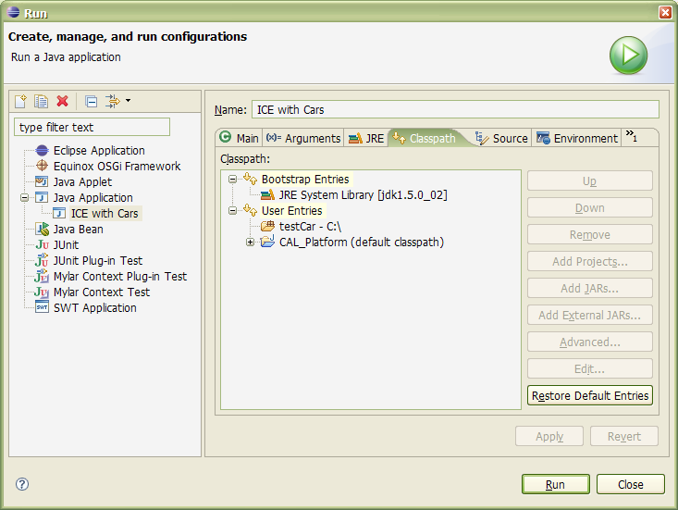

Specifying an Alternate Workspace Declaration
Next, we need to tell ICE to use an alternate workspace declaration. This can be achieved by specifying the system property “org.openquark.cal.ice.workspace”. The value of this property shall be the full path of one of the generated workspace declaration files, surrounded by double quotes.
For example:
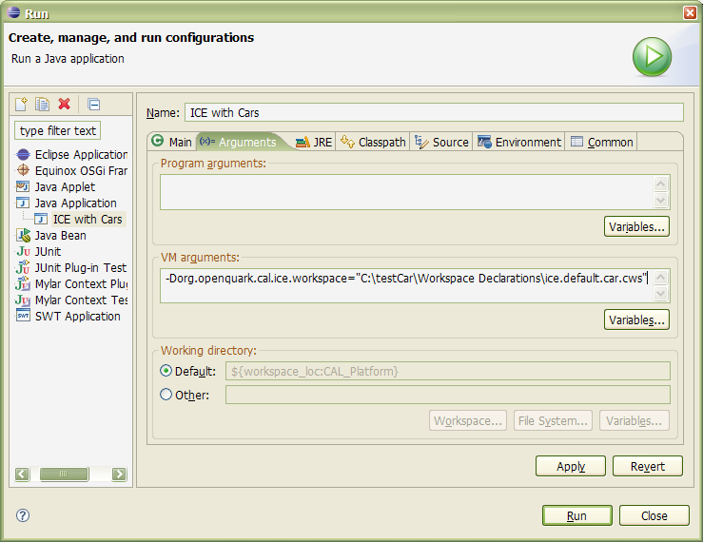
After this step, the run target’s configuration is complete and can be launched.

GemCutter
The step to configure the classpath is the same as with ICE (see Section 4.1.1.1 above).
To configure GemCutter to use an alternate workspace declaration, we can use the system property “org.openquark.gems.client.gemcutter.workspace”. The value of this property shall be the full path of one of the generated workspace declaration files, surrounded by double quotes.
For example:
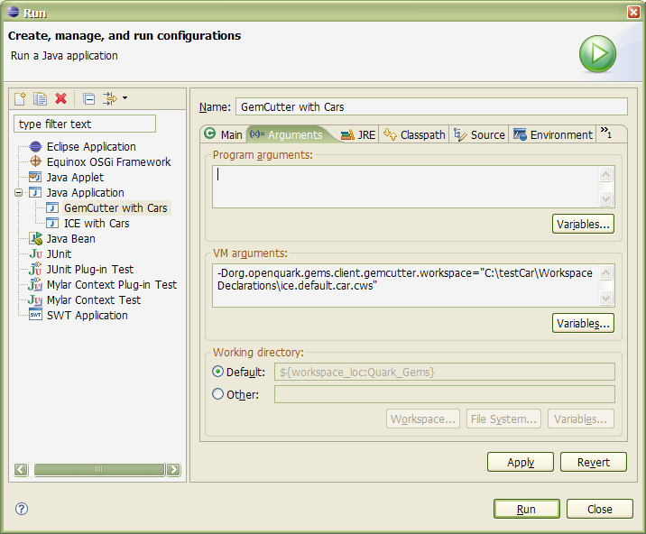

Using Car-jar files
The CAL runtime will recognize Car-jar files added directly to the Java classpath.
For example, suppose one had generated some Car-jar files in ICE using:
:car –jar -d c:\testCar
Then, the Car-jar files in c:\testCar should be added to the Java classpath.
Also, one needs to inform the CAL program in question (e.g. ICE or GemCutter) to use one of the generated workspace declarations so that the CAL workspace will be initialized with the contents of the Cars.
We will outline the entire process of setting up ICE and GemCutter in the Eclipse environment in the following sections.

Setup for ICE and GemCutter
First, set up an Eclipse run target for either ICE or GemCutter – the steps are the same for both applications. For this example let us pick ICE.

Modifying the Java Classpath
To add the generated Car-jar files (which include the corresponding workspace declaration files) to the Java classpath, edit the properties of the run target and navigate to the Classpath tab. Once there, select the “User Entries” tree node in the Classpath panel, then click the “Add External JARs…” button. You can then multi-select all the generated Car-jar files, as shown:
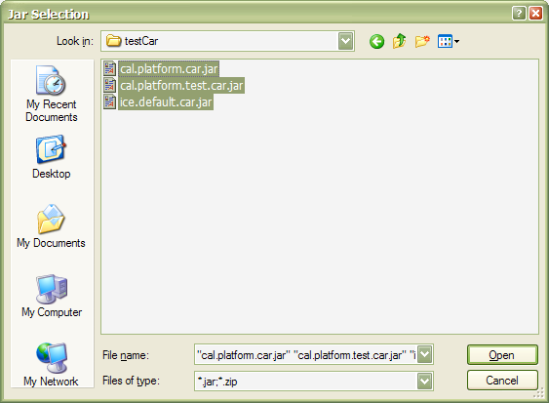
The final result should look like this:
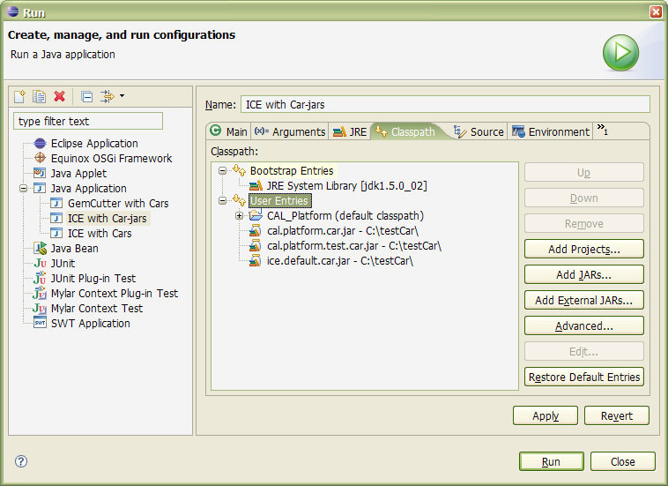

Specifying an Alternate Workspace Declaration
Next, we need to tell ICE to use an alternate workspace declaration. This can be achieved by specifying the system property “org.openquark.cal.workspace.spec”. The value of this property shall be a vault entry for the workspace declaration file, surrounded by double quotes.
For example:
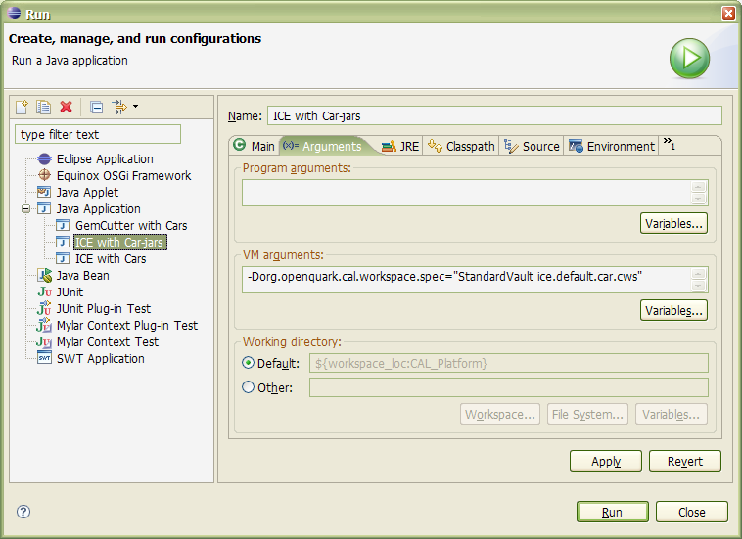
After this step, the run target’s configuration is complete and can be launched.

Deployment Scenarios for Cars
As designed, Car files work equally well within the confines of Eclipse as they do in a deployment scenario where the Quark Platform comes packaged in jar files.
There are a number of different ways we can use Car files in a deployment. One way is to simply provide a single Car containing all the required CAL modules and their resources.
We can also be a bit more sophisticated and provide multiple Carspec files (see Section 2.3) with the Car, so that the same Car can accommodate different use cases which require different sets of modules in their workspaces.
On the other hand, we can also package up the CAL modules into multiple Car files. For example, one approach would be to create a set of Cars where each Car corresponds to the modules listed in a particular workspace declaration file. (See Section 3.2)
One can use Car-jar files instead of regular Car files with any of the approaches listed above.
If the usage scenario for the deployment calls for the ability of the user to edit some of the CAL modules, these modules can be deployed separately outside the Cars. It is permissible for a CAL workspace to simultaneously refer to modules found in Cars, and to modules located in regular vaults (e.g. StandardVault).

